Using Geographic Data to Find Prospect Locations for New Fitness Centers in the City of Waterloo, Ontario

Lucas Lau

November 20, 2022

**1. Introduction**

Fitness centers are used daily around the world, where the majority of the members fall between the ages of 18 to 34 years old (Rizzo, 2021). With access to all sorts of equipment and amenities, fitness centers provide the opportunity to perform physical activity which contributes to a healthier lifestyle (Riseth et al., 2019). They offer group classes, personal trainers, and enforce regulations and safety standards while disinfecting the area regularly (Smith, 2018). During the pandemic, the government placed restrictions that affected the daily operations of fitness centers (Armstrong et al., 2021) thus, leading to homes becoming the focal point of fitness and exercise for many people (Clark et al., 2021). However, now that all restrictions have been lifted, people are eager to get back into shape and return to the gym, especially now that university students are returning back to campus.

The City of Waterloo is home to the University of Waterloo and Wilfrid Laurier University. With thousands of students enrolled every term, the campus gyms are rarely empty. With limited equipment, time is wasted waiting for others to finish their sets, leading to students leaving early without finishing their workout, or having a lot of rest time in between each exercise. Optimal rest intervals range between 30-90 seconds to induce muscular hypertrophy (Bubnis, 2021), thus waiting too long to use an equipment will negatively impact muscle growth. An alternative to avoid these situations would be attending public gyms outside of campus, however, most existing public fitness centers in the City of Waterloo are kilometers away from campus and students are unmotivated to travel the distance. Although campus fitness centers are already paid for through tuition, there still exist students on co-op or taking time off who would not have access to the campus facilities and would benefit from the public ones. Non academic activities, such as recreation, have a variety of health and social benefits for students (Henchy, 2011). Furthermore, neighborhoods in the city that are isolated from fitness centers could benefit from a closer one, or perhaps become motivated to go if it does not require a long commute.

This proposal aims to evaluate the distribution of fitness centers with respect to the City of Waterloo in order to find prospect locations. Location is an important determinant of new fitness centers because the city is continuously expanding and new areas will require fitness centers in its vicinity. The City of Waterloo has an Official Plan that outlines the long-term guide for land use and development which sets out policies that direct growth in 2031 (City of Waterloo, 2022). Land use data is very useful for analyzing the distribution of the various factors impacting the suitability of new fitness center locations. A combination of GIS-based tools and multi-criteria analysis (MCA) was used to find the most suitable areas for prospect fitness centers. MCA has significantly improved the ability of multi-layered analysis to make decisions based on given criteria (Svoray et al., 2010). MCA was used in many prior researches, for example, determining land use suitability for cattle farming (Alturk et al., 2022). In the study, natural, anthropogenic, economic, environmental and social conditions were used as the main factors and also divided sub-factors such as topography, distance to urban areas and water resources, land use, etc. were used to determine the land use suitability of livestock farming (Alturk et al., 2022). A land use suitability map was created using the multi-criteria decision method to determine the land suitability classes for 2050 (Alturk et al., 2022).

Multi-criteria analysis provides a framework for handling different compositions of the elements of a decision problem. It is primarily concerned with combining the information from several criteria to form a single evaluation by organizing them into a hierarchical structure (Feizizadeh et al., 2014) with weights. The weighted overlay tool in MCA assigns each included factor a percentage influence according to its importance and the results vary depending on the influence of each factor. MCA was previously used in landslide susceptibility mapping for the prediction of future hazards and land use planning (Feizizadeh et al., 2014). Although this study uses various analysis methods other than MCA, the general idea includes assessing the uncertainty of landslide susceptibility maps produced with MCA techniques (Feizizadeh et al., 2014). Weights were computed to express the relative importance of the factors for landslide susceptibility, then the uncertainty and sensitivity of landslide susceptibility was analyzed as a function of weights using Monte Carlo Simulation and Global Sensitivity Analysis (Feizizadeh et al., 2014). Results demonstrated that MCA produces accurate results in landslide susceptibility but can be improved by integrating an uncertainty-sensitivity analysis.

Through the use of geographical information systems (GIS), multi-criteria analysis and spatial data, this proposal aims to address the following research questions:

1. How can geographic data be used to find prospect locations for new fitness centers in the City of Waterloo?
2. How much distance should there be between two fitness centers?
3. What factors that affect the suitability of prospect fitness centers should be included or excluded from the weighted multi-criteria overlay analysis?

In view of such information, this study aims to:

1. determine land use suitability for new fitness center locations,
2. shorten travel distance from residential areas to fitness centers,
3. propose the most convenient and ideal location for a new fitness center.

The remainder of this proposal is structured as follows. Section 2 describes the study area, the components of the data flow diagram, and the multi-criteria analysis method used to compute the analysis. Section 3 outlines the results and explains each map created through the use of MCA. The interpretation of results, broader implications and limitations of the research and results will be discussed in Section 4. Section 5 lists the conclusions of the study.

**2. Methods**

The study area that we chose to focus on for this research is the City of Waterloo. We chose this area for its growing population of students and available areas for new fitness centers. It is projected that from the end of 2021 to 2041, the population of Waterloo will grow from 147,520 to 160,183 and the number of households will grow from 43,896 to 58,268 (Whitnell, 2022). As of 2021, 27.6% of the population in Waterloo is between the ages 20 and 34 with the median at 36 (Whitnell, 2022). Waterloo’s growing population and large percent of young adults makes it an ideal area to open a new fitness center.

The City of Waterloo contains 20 public schools and 2 universities. The public schools are attended by an estimated 28,390 students in 2021 (Whitnell, 2022). The University of Waterloo has a total of 42,000 students enrolled as of 2020 (Whitnell, 2022). The population of students in the City of Waterloo is expected to increase with the general population. Currently, there is a lack of fitness centers that can support the current and growing student population. There are 14 privately owned fitness centers in the City of Waterloo, 2 main fitness centers and 1 residential fitness center in the University of Waterloo, and 1 fitness center in Wilfred Laurier University. These fitness centers cannot support the large population of students. Furthermore, frequently crowded fitness centers discourage students from consistently visiting these centers.

The data that we collected for this research is from the Ontario, City of Waterloo and Region of Waterloo Open Data Portal. Important data that could not be obtained from public datasets was acquired through Google Maps. From Open Data Portal we downloaded shapefiles for GRT stops, population, bicycle parking areas, water bodies and parks. From Google Maps we located existing fitness centers and car parking spots then manually digitized them as separate layers in ArcMap. All the layers from Open Data Portal and Google Maps were then converted to raster datasets and its projections changed to NAD 1983 UTM Zone 17N.

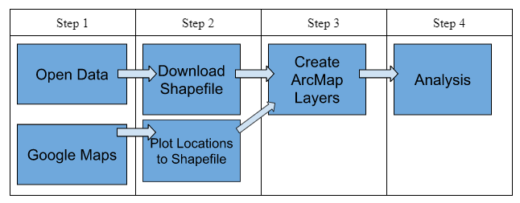

Figure 1. Data-flow diagram.

Originally the analysis part of the research was to use the Boolean Model for positioning. After further research on similar research and projects, we decided to use Multi-Criteria Analysis instead for our analysis. Although the Boolean Model can answer our research question by identifying suitable and unsuitable areas for a new fitness center location, its result can only be binary. MCA allows us to answer our research question but with more dimensions and detail in our results. Using MCA, we were able to produce a map that ranks each area within the City of Waterloo based on its suitability for a new fitness center. If we were to use the Boolean Model, we will only be able to produce a map with two categories: suitable and unsuitable.

Multi-Criteria Analysis is a decision making tool that evaluates multiple criterias that are conflicting (Macharis et al, 2018). In our research, we will be using weighted overlays to produce an MCA suitability map. Weighted overlay takes in multiple layers of geographical data and produces a single layer that ranks each area of the map based on suitability determined by the input layers (Macharis et al, 2018). The geographical data that we will use for weighted overlays are the shapefiles from Open Data portal and layers from Google Maps. Weighted overlays will then assign a suitability to each area based on these datasets.

After every layer from Open Data Portal and Google Maps are added into ArcMap, the Multi-Ring Buffer tool from ArcMap is used on each layer. The Multi-Ring Buffer tool takes a layer as input, a layer is then produced as output which classifies each area of the map based on its proximity to each feature from the input. For each layer we chose to use 4 different ranges, therefore the output will have 4 different classifications from 1 to 4. For example, the Multi-Ring Buffer tool used on the car parking lots layer produces a layer that classifies areas close to parking lots as 4 and further areas as 1. This process is used for the layers population, GRT stops, existing fitness centers, car parking lots and bicycle parking areas.

After the Multi-Ring Buffer tool is used to produce layers for all the selected layers, the outputs are used in the Weighted Overlay tool from ArcMap. The Weighted Overlay tool produces an MCA result which ranks each area in the City of Waterloo based on the Multi-Ring Buffer tool layers. The weights that we used in the Weighted Overlay tool is: population 25%, GRT stops 25%, existing fitness centers 30%, car parking lots 10% and bicycle parking area 10%. We chose to give existing fitness centers more weight since competition has a heavy impact on a location’s suitability. We chose to give parking areas less weight since the majority of students and young adults living in Waterloo do not drive cars and prefer public transport, this gives bus stops and proximity to a large population a higher weighting.

After the MCA result is produced by the Weighted Overlay tool, we put the water bodies layer and parks layer on top to identify those areas as unsuitable. Since a fitness center cannot be built on water bodies and parks, we excluded these layers from the Weighted Overlay process. Instead, we vetoed water bodies and parks as unsuitable on the map.

**3. Results**

Five factors were taken into consideration for finding prospect locations for new fitness centers in the City of Waterloo based on the Weighted Multi-Criteria Overlay Analysis: Fitness centers, GRT stops, Population, Parking lots, and Bike Racks. Each factor was reclassified into 4 classes using different suitable and unsuitable values and have been assigned different influence percentages based on the importance of each factor. These details have been discussed in the following sections.

**3.1 *Fitness Centers***

Existing fitness centers located around the City of Waterloo is one of the five factors that were used to determine new suitable fitness center locations. Although there are definitely certain benefits to opening new businesses where there is more competition, such as an “[increase in] the incentives to supply high quality for given prices, it also reduces the price-cost margin, which, in turn, reduces the incentives to invest in quality” (Brekke et al., 2018). Therefore, in order to avoid these unnecessary disadvantages, opening new fitness centers that are farther from existing ones would be more ideal. For the weighted overlay calculation, multi ring buffers were placed on each fitness center with the following distances: 0.1 km, 0.5 km, 1 km, and 1.5 km. Distances less than 0.1 km were considered very unsuitable, greater than 0.1 km but less than 0.5 km were considered unsuitable, greater than 0.5 km but less than 1 km were considered suitable, and distances greater than 1 km were considered very suitable. The purpose behind these buffer regions was to ensure that new prospect locations would not be near any competing fitness centers. According to figure 2, 78.7% of the study area was considered to be very suitable, 14.2% was suitable, 6.8% was unsuitable, and 0.3% was very unsuitable which meant that majority of the study area was very suitable for opening up a new fitness center more than 1 km away from the existing fitness centers in the City of Waterloo.

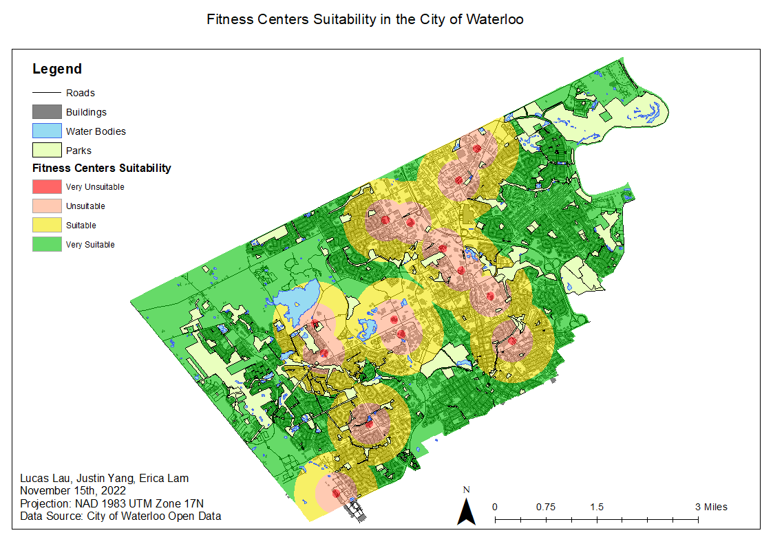

Figure 2. Map showing suitability based on fitness centers in the City of Waterloo.

**3.2 *GRT Stops***

GRT Stops around the City of Waterloo is also an important factor to consider when determining new suitable fitness center locations as many people will be relying on public transportation to get to these fitness centers. Because the City of Waterloo is home to many students and young adults who may or may not have their driver’s licenses, they depend on public transportation to get to places. According to an article that analyzed recent changes in age composition of drivers in 15 countries, including Canada, “there was a decrease in the percentage of young people with a driver's license, and an increase in the percentage of older people with a driver's license” (Sivak & Schoettle, 2012). For the weighted overlay calculation, multi ring buffers were placed on each GRT stop with the following distances: 0.1 km, 0.35 km, 0.65 km, and 1 km. Distances greater than 0.65 km were considered very unsuitable, greater than 0.35 km but less than 0.65 km were considered unsuitable, greater than 0.1 km but less than 0.35 km were considered suitable, and distances less than 0.1 km were considered very suitable. The purpose behind these buffer regions was to ensure that new prospect locations would be as close to GRT stops as they can be to allow for easy access to public transportation. According to figure 3, 7.7% of the study area was considered to be very suitable, 23.9% was suitable, 12.3% was unsuitable, and 56.1% was very unsuitable which meant that more than half of the study area was greater than 1 km away from any GRT stop.

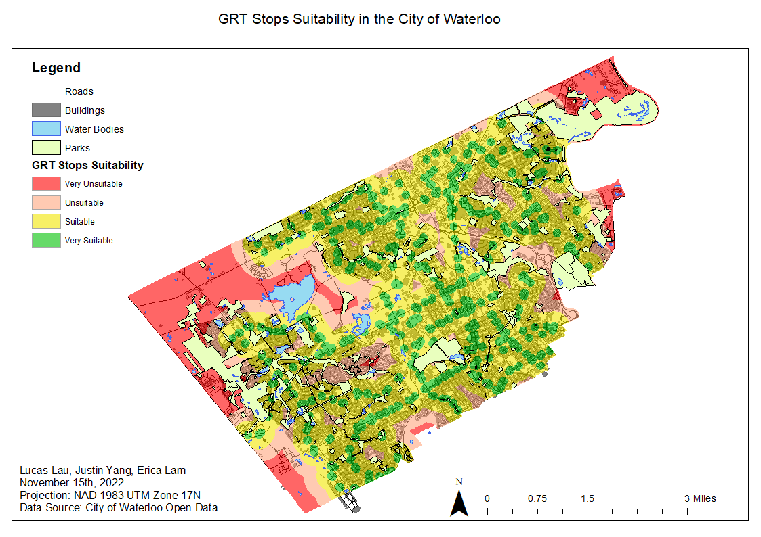

Figure 3. Map showing suitability based on GRT stops in the City of Waterloo.

**3.3 *Population***

Population count is an important factor for determining which areas in the City of Waterloo are more populated because populated areas are more likely to increase the success of a new fitness center. For the weighted overlay calculation, population count was reclassified using the natural breaks classification method instead of the multi ring buffers. This is because for population count, it would be more beneficial to determine suitability based on the number of population counts within a census tract than to determine suitability based on distances. The intervals that were used are as follows: 5 - 1868, 1868 - 5233, 5233 - 6548, 6548 - 8395, which represents very unsuitable, unsuitable, suitable, and very suitable respectively. According to figure 4, 22.7% of the study area was considered to be very suitable, 25.5% was suitable, 40.2% was unsuitable, and 11.6% was very unsuitable which meant that 48.2% of the study area was either suitable or very suitable with population counts ranging anywhere between 5233 - 8395.

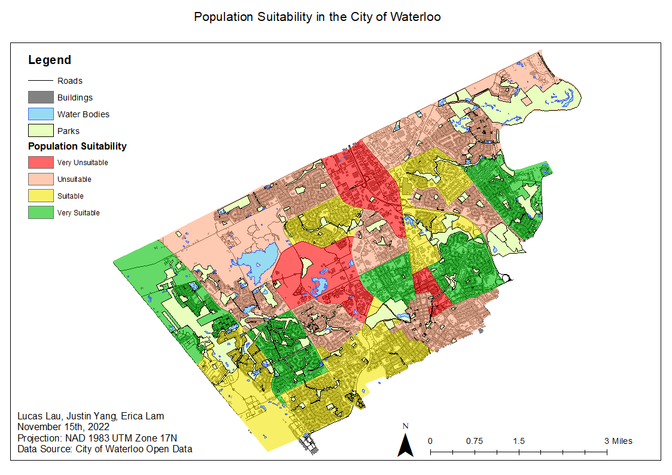

Figure 4. Map showing suitability based on population in the City of Waterloo.

**3.4 *Parking Lots***

For people who do not like to use public transportation and prefer to drive instead, it is important to also consider the areas of existing parking lots in the City of Waterloo that could potentially be used for prospect fitness center locations. For the weighted overlay calculation, multi ring buffers were placed on each parking lot with the following distances: 0.1 km, 0.2 km, 0.3 km, and 0.4 km. Distances greater than 0.3 km were considered very unsuitable, greater than 0.2 km but less than 0.3 km were considered unsuitable, greater than 0.1 km but less than 0.2 km were considered suitable, and distances less than 0.1 km were considered very suitable. The distance ranges selected for the buffers around parking lots were a lot less than the other factors because people driving to fitness centers would definitely prefer to park closer to the fitness centers without needing to walk extra distances to get there. The purpose behind these buffer regions was to ensure that new prospect locations would be as close to parking lots as they can be to allow for easy access to these centers. According to figure 5, 2.1% of the study area was considered to be very suitable, 2.1% was suitable, 2.5% was unsuitable, and 93.3% was very unsuitable which meant that the majority of the study area was greater than 0.4 km away from any parking lot. This result was expected for parking lots due to the fact that there were only a handful of significant parking lots scattered around the study area. Parking lots were chosen based on whether or not they were parking lots of big plazas that would be more likely to accommodate new fitness centers than smaller parking lots.

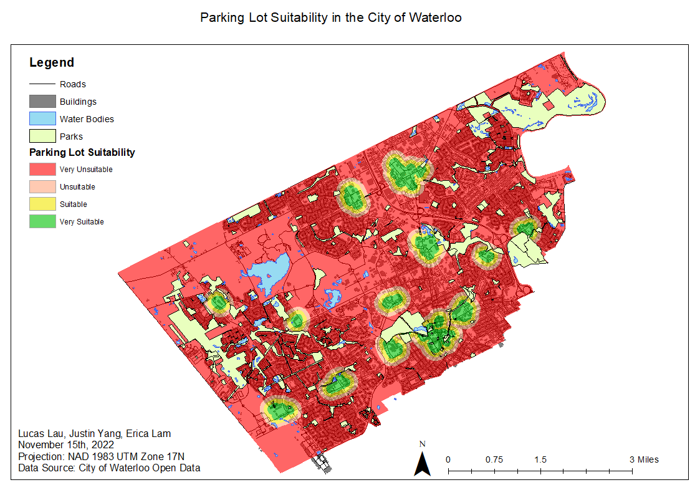

Figure 5. Map showing suitability based on parking lots in the City of Waterloo.

**3.5 *Bicycle Racks***

For people who do not like to drive nor use public transportation, it is also important to consider the areas of all the bike racks stationed around the City of Waterloo in the case that these groups of people prefer to bike to gyms. For the weighted overlay calculation, multi ring buffers were placed on each bike rack location with the following distances: 0.1 km, 0.2 km, 0.3 km, and 0.4 km. Distances greater than 0.3 km were considered very unsuitable, greater than 0.2 km but less than 0.3 km were considered unsuitable, greater than 0.1 km but less than 0.2 km were considered suitable, and distances less than 0.1 km were considered very suitable. Much like the parking lots, the distance ranges selected for the buffers around bike racks were a lot less than the other factors because people biking to fitness centers would definitely prefer to have their bikes closer to the fitness centers without needing to walk too far to return to their bikes. The purpose behind these buffer regions was to ensure that new prospect locations would be as close to bike racks as they can be to allow for easy access to these centers. According to figure 6, 1.3% of the study area was considered to be very suitable, 2.9% was suitable, 4.1% was unsuitable, and 91.7% was very unsuitable which meant that the majority of the study area was greater than 0.4 km away from any bike rack. This result was expected for bike racks as well due to the fact that each bike rack was scattered throughout the study area and that the area of each bike rack only takes up a small percentage of the total area.

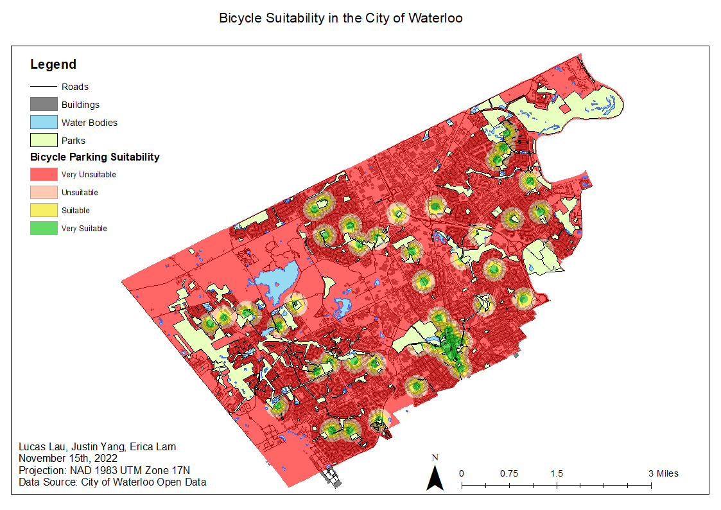

Figure 6. Map showing suitability based on bicycle racks in the City of Waterloo.

**3.6 *Weighted Multi-Criteria Overlay Analysis Result***

The five factors listed above were combined using the weighted overlay tool to produce a map representing all the suitable and unsuitable fitness center locations in the City of Waterloo. As mentioned in the method section, the rasters were combined without the water bodies and parks layers which resulted in 0.9% of the total area being very suitable, 59.8% being suitable, 39.2% being unsuitable, and 0.01% being very unsuitable. These suitability percentages were calculated based on the different weights assigned to each of the factors mentioned in the methods section: population set to 25% influence, GRT stops set to 25% influence, existing fitness centers set to 30% influence, car parking lots set to 10% and bicycle parking areas set to 10% influence. Parking lots and bicycle racks were assigned the lowest influence percentage because although they are still important factors in determining suitability for prospect fitness centers, they are not as important when it comes to determining locations farther away from other existing fitness centers and locations that are highly populated with easy access to public transportation. Based on figure 7, it is evident that the southern part of the study area was considered more suitable than the northern part of the study region.

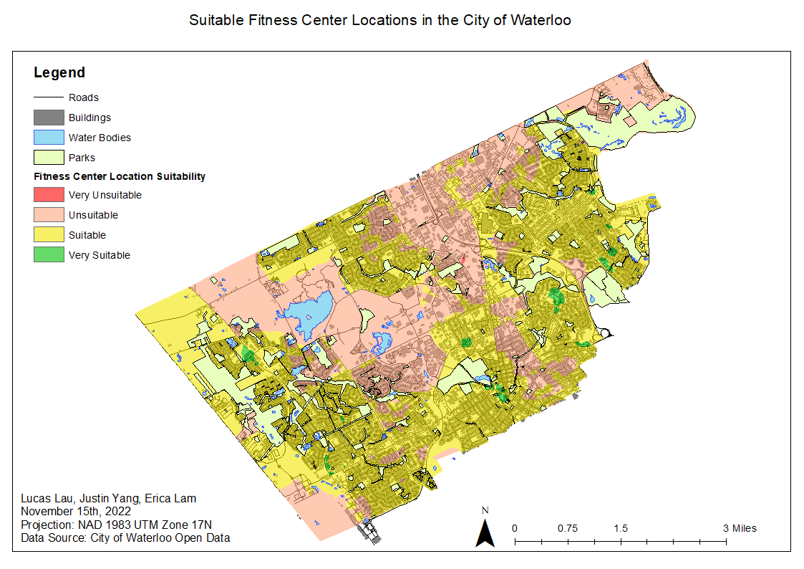

Figure 7. Map showing suitable fitness center locations in the City of Waterloo based on the five factors mentioned above.

**4. Discussion**

The various factors used in the Weighted Multi-Criteria Overlay Analysis are expected to determine the most suitable areas for new fitness centers in the City of Waterloo. This method can output a new raster layer with multiple classes representing different areas that are very suitable, suitable, unsuitable, and very unsuitable which inturn can provide a visual representation on where these types of areas are in the City of Waterloo. Opening a new fitness center in the most suitable place can ultimately help improve the overall success of the fitness center by eliminating potential competition, providing better accessibility, and by ensuring there will be a constant flow of customers. The potential broad implications of this study could include identifying suitable areas to grow more vegetation based on a list of relevant factors, or to identify potential artificial groundwater recharge zones (Zaidi et al., 2015). Generally, performing a weighted multi-criteria overlay analysis can be used for anything involving the analysis of spatial data in order to determine the most optimal solutions for many real world problems (i.e. most optimal highway routes, suitable areas for new EV charging stations). However, although the weighted multi-criteria overlay analysis can be quite useful in helping to determine suitable and unsuitable areas, there still exists some limitations, issues, and constraints.

**4.1 *Limitations, Issues, and Constraints***

The main limitation to the Weighted Multi-Criteria Overlay Analysis is that it depends solely on the number of factors that were considered in the operation and the influence placed on each one. The number of factors used in the calculation can affect the output raster results because each factor will have a raster of its own, some having more impact than others, and the output is generated by combining all of these rasters together. This is a main limitation because it is very hard to account for all the factors that can affect the suitability of new fitness centers, especially given a four month time constraint. Based on the factors that were considered for this study, there are also some constraints placed on these factors. For parking lots, there were not any parking lot datasets that contained all the parking lots in the City of Waterloo, so only some parking lots were digitized and used in this study. For existing fitness centers, it was concluded that they were referred to in general instead of as a specific chain or company because it would require a lot more research to gather competitor data; which fitness brands are competing with each other, and it would not be possible to determine which fitness brands would be most suitable for specific locations given the time constraint. For population data, it was concluded that household income would be excluded because it would require a lot more time to collect accurate household income data. Many residents in the City of Waterloo are of student status who are constantly moving locations every new school term and this makes it extremely hard to obtain accurate household income data. However, in the case that household income data could be collected, this data would have been used to help determine whether an affordable or high-end fitness center would be better suited for a specific suitable location. Therefore, only population count for each census tract was accounted for instead. Lastly, it is important to note that since the City of Waterloo is still developing, the results gathered in this study will only be relevant for a certain period of time before the land develops further. In other words, for example, using land use data in 2021 may not produce the same results as land use data obtained in 2022.

**5. Conclusions**

The presented set of spatial data (GRT stops, population, bicycle parking, waterbodies, parks, existing fitness centers, parking lots) were highly relevant contributors in locating the ideal space for a new fitness center. Their integration into a multi-criteria analysis allowed us to map the areas in the City of Waterloo for the most suitable and unsuitable spaces, which can be used by fitness brands in the near future when trying to expand their business and build more locations. The use of multi-criteria analysis in identifying the area of land-use conflicts can help in the decision-making process of building a new fitness center, because this methodology can represent a starting point for this assessment. Oftentimes, researchers may overlook basic factors that are not always evident when conducting this type of study, for example, existing vacant commercial buildings that can be used for a new fitness center rather than constructing a whole new building or plaza.

The main limitations of the methods lie in the availability of data required when each criteria was constructed. Waterloo is continuously developing, so the relevant features in this research may change and be irrelevant in the far future. Moreover, no principles were used when assigning the influence of each criteria, thus we chose them according to our own opinion and expertise. Improvements should be pursued by using the method of pair-wise comparison to determine the relative importance of each criteria in the form of a criteria weight (Iojă et al., 2014) as the method uses an expert-opinion system.

To advance our research in the future, there is the option to collect data about each existing fitness center to determine what specific gym brand is best suited for the new location. However, this may require communication with the fitness brand representatives to know more about their competitions and financial state because we can not assume this information as it leads to unreliable results. There also exists the option to collect data on household income to conclude whether an affordable to high-end fitness center is more suited. However, Waterloo is home to many students who change where they live every term so obtaining household income would produce inaccurate results in the analysis. Perhaps, this study could be relocated to a new city with more stable household incomes in order to conduct this section of the study. Perhaps a developing city without that many students and without that many existing fitness centers. Ultimately, further research is required to analyze whether such a multi-criteria assessment can be applied to other study areas to begin with.

**References**

Alturk, B., Kurc, H. C., Konukcu, F., & Kocaman, I. (2022). Multi-criteria land use suitability

analysis for the spatial distribution of cattle farming under land use change modeling scenarios in Thrace Region, Turkey. *Computers and Electronics in Agriculture*, *198*(Complete). <https://doi.org/10.1016/j.compag.2022.107063>

Armstrong, W. , Dayal, N. & Braun, W., 2021. Beyond COVID-19: Preparing Fitness Centers for

the Next Pandemic. *Strength and Conditioning Journal, 43* (5), 36-43.

Brekke, K. R., Siciliani, L., & Straume, O. R. (2018). Can competition reduce quality?: JITE.

*Journal of Institutional and Theoretical Economics, 174*(3), 421-447. doi:<https://doi.org/10.1628/093245617X15010500333985>

Bubnis, D., 2021. Rest Between Sets: What’s Right for Me? [online]. Healthline*.* Available from:

<https://www.healthline.com/health/fitness/rest-between-sets> [Accessed 21 September 2022].

City of Waterloo, 2022. Official Plan [online]. City of Waterloo. Available from:

<https://www.waterloo.ca/en/government/official-plan.aspx> [Accessed 21 September 2022].

Clark, M., & Lupton, D., 2021. Pandemic fitness assemblages: The sociomaterialities and

affective dimensions of exercising at home during the COVID-19 crisis. *Convergence: The International Journal of Research into New Media Technologies*, *27*(5), 1222–1237.

Feizizadeh, B., Jankowski, P., & Blaschke, T. (2014). A GIS based spatially-explicit sensitivity

and uncertainty analysis approach for multi-criteria decision analysis. *Computers and Geosciences*, *64*(Complete), 81–95. <https://doi.org/10.1016/j.cageo.2013.11.009>

Henchy, A., 2011. The Influence of Campus Recreation beyond the Gym. *Recreational Sports*

*Journal*, *35*(2), 174–181.

Iojă, C. I., Niţă, M. R., Vânău, G. O., Onose, D. A., & Gavrilidis, A. A. (2014). Using

multi-criteria analysis for the identification of spatial land-use conflicts in the Bucharest Metropolitan Area. *Ecological Indicators*, *42*(Complete), 112–121. <https://doi.org/10.1016/j.ecolind.2013.09.029>

Macharis, & Baudry, G. (2018). Decision-making for sustainable transport and mobility : multi

actor multi criteria analysis (Macharis & G. Baudry, Eds.). Edward Elgar Publishing.

Riseth, L., Nøst, T. H., Nilsen, T. I. L., & Steinsbekk, A., 2019. Long-term members’ use of

fitness centers: a qualitative study. *BMC Sports Science, Medicine and Rehabilitation*, 11, 2.

Rizzo, N., 2021. 77 Gym Membership Statistics, Facts, and Trends [online]. RunRepeat.

Available from: <https://runrepeat.com/gym-membership-statistics#gym-member-age-statistcs> [Accessed 21 September 2022].

Sivak, & Schoettle, B. (2012). Recent Changes in the Age Composition of Drivers in 15

Countries. *Traffic Injury Prevention*, *13*(2), 126–132. <https://doi.org/10.1080/15389588.2011.638016>

Smith, A., 2018. What are the Benefits of a Fitness Center? [online]. SportsRec. Available from:

<https://www.sportsrec.com/351441-what-are-the-benefits-of-a-fitness-center.html> [Accessed 21 September 2022].

Svoray, T., & Ben-Said, S. (2010). Soil loss, water ponding and sediment deposition variations as

a consequence of rainfall intensity and land use: a multi-criteria analysis. *Earth Surface Processes and Landforms*, *35*(2), 202–216. <https://doi.org/10.1002/esp.1901>

Whitnell, T., 2022. Planning and land use data [online]. City of Waterloo. Available from:

<https://www.waterloo.ca/en/government/planning-and-land-use-data.aspx> [Accessed 21 September 2022].

Whitnell, T,. 2022. Workforce and demographics [online]. City of Waterloo. Available from:

<https://www.waterloo.ca/en/government/workforce-and-demographics.aspx#:~:text=As%20of%202021%3A,34%20years%20old%20is%2027.6%25> [Accessed 21 September 2022]

Zaidi, F. K., Nazzal, Y., Ahmed, I., Naeem, M., & Jafri, M. K. (2015). Identification of potential

artificial groundwater recharge zones in Northwestern Saudi Arabia using GIS and Boolean logic. *Journal of African Earth Sciences*, *111*(Complete), 156–169. <https://doi.org/10.1016/j.jafrearsci.2015.07.008>